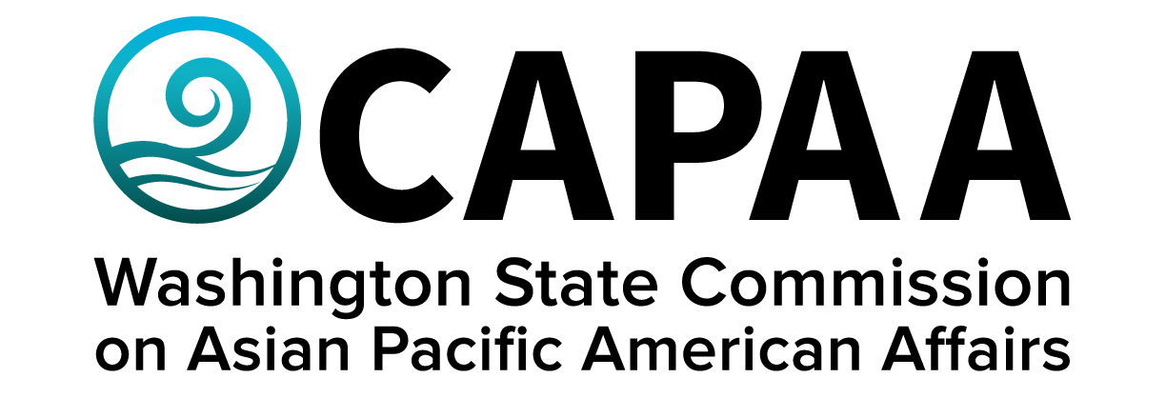

Staff Report

Saturday, March 23, 2024

Prepared by:

Executive Director Toshiko Hasegawa
Project Manager K’gnausa Yodkerepauprai
Project Coordinator Brenda O’Brien

March Public Board Meeting: Virtual

Improving the well-being of Asian Pacific Americans by examining issues, advancing advocacy, and ensuring access to government.
Staff Report
March 23, 2024

Staff report to the Commission covering activities, progress, and updates from January 27, 2024 to March 22, 2024.

STAFF AND COMMISSIONER ACTIVITY

Commissioner Activity: Commissioners were not asked to submit activity reports for this quarter. They will submit activity reports for an extended period of January 13, 2024 to May 30, 2024 for the June board meeting.

Total events reported = N/A;

- FINANCE

FY24 Supplemental Budget Decision Package Requests:
The 2024 Supplemental Budget provided CAPAA with $31,000 to cover the cost of a necessary total website rebuild as well as the $4,000/yr annual maintenance and hosting services provided by WA Tech. If the maintenance cost changes over time then we can update our assumptions and go back for an increase in the future.

CAPAA in excellent financial condition. To date, the agency is projected to underspend its FY24 appropriation by $39k if it is approved.

Sponsorships: Note: Because of the limit on sponsorship-related spend, CAPAA will only grant applications to first-time applicants who meet all criteria.

Five requests for sponsorship were received in this period. One was approved for the closing reception for “Interwoven” being hosted by Asians for Collective Liberation in Spokane. It will take place at the end of May (final date TBD) at either the Magic Lantern Theater or the Spokane Public Library. Four other requests were denied to due to being organizations or events CAPAA has funded before, or because the requested sponsorship amount exceeded our limit. Details for all requests can be found in Appendix below.

- CAPAA’S GOLDEN CELEBRATION

Gold Sponsors: $15,000 (3)
Silver Sponsors: $6,000 (2)
Bronze Sponsors: $11,000 (11)
Community Sponsors: $1,000 (4)
In-kind donations: $1,500 (2)
Ticket sales: $21,240 (238)
Exhibitors: $350 (4)
Advertisers: $1,000 (2)

Additional Expenses:
- Venue: $3075
- Leis: $1378
- Photographer: $413
- Videographer for event: $1,500
- Vignette: $5000
- Graphic Designer: $5,100
- Performer and Awardees accommodations: $430
- Photo booth: $1000
- Asia Pacific Cultural Center Contract: $24,000
- Awards $412
Revenue over expenditures: $9,992

Awards: Executive Committee opted to award Assunta Ng with the Lifetime Achievement Award
- REQUIRED EQUITY TRAININGS

The Department of Enterprise Services has developed the training, A Path Toward Equity: Disrupting Structural Racism through Awareness and Belonging, to provide a foundational training for all executive branch state employees and appointed Commissioners. The course aims to develop shared understanding and language around diversity, equity, and inclusion and help employees gain skills necessary for a respectful and inclusive workplace. Brenda has provided the information necessary to login and take the training. Contact her directly if you need additional support. The training includes a prerequisite viewing of the documentary, “Who We Are: A Chronicle of Racism in America”, which must be completed prior to registering for the DEI foundational training modules.

Commissioners are also part of CAPAA’s agency Pro-Equity, Anti-Racism (PEAR) team – and are required to watch the orientation video. The video can be accessed here: 2022 PEAR Team Orientation Recorded Session - YouTube

- UPCOMING EVENTS

Saturday, March 23
4:30 – 7:30 Golden Celebration
King County - Highline College, Bldg. 8, Mt. Townsend Room
2400 S 240th St, Des Moines, WA 98198

Saturday, May 4
AA & NHPI Heritage Month
11:00 – 6:00 pm
Seattle Center

May 24, 25, or 26 (TBD)
Interwoven Closing Reception
Time TBD
Magic Lantern Theater or Spokane Public Library

Saturday, June 8
10:00 – 2:00
Spokane County - Spokane Convention Center
334 W Spokane Falls Blvd, Spokane, WA 99201

Saturday, September 21
10:00 – 2:00
Kitsap County - Filipino American Association of Kitsap County
1240 Sheridan Road, Bremerton, WA, United States, Washington

Saturday, November 16
10:00 – 2:00
Snohomish County - Everett Community College
2000 Tower St, Everett, WA 98201

Appendix I: Sponsorship Requests

